GPS

Mse

$GPRMC,085106.0,A,4729.29126,N,01904.76288,E,001.08,285.1,040417,004.1,E,A*32

**$GPGGA,085106.0,4729.29126,N,01904.76288,E,1,07,1.0,100.8,M,42.0,M,,*56**

$GPVTG,285.1,T,281.0,M,001.08,N,0002.00,K,A*1D

$GPGSA,A,3,78,13,80,07,05,79,20,,,,,,1.7,1.0,1.3*3C

$GPRMC,085106.1,A,4729.29126,N,01904.76284,E,001.05,287.1,040417,004.1,E,A*30

$GPGGA,085106.1,4729.29126,N,01904.76284,E,1,07,1.0,100.8,M,42.0,M,,*5B

$GPVTG,287.1,T,283.0,M,001.05,N,0001.94,K,A*1E

$GPGSV,3,1,11,33,26,222,22,78,25,151,39,13,38,297,24,80,85,301,30*7D

$GPGSV,3,2,11,07,38,061,41,05,55,251,32,84,09,016,22,08,13,060,28*70

$GPGSV,3,3,11,79,80,187,41,20,26,310,25,85,31,040,27*49

$GPRMC,085106.2,A,4729.29128,N,01904.76280,E,001.41,293.6,040417,004.1,E,A*3B

$GPGGA,085106.2,4729.29128,N,01904.76280,E,1,07,1.0,100.7,M,42.0,M,,*5D

$GPVTG,293.6,T,289.4,M,001.41,N,0002.60,K,A*1A

$GPRMC,085106.3,A,4729.29129,N,01904.76274,E,001.49,291.8,040417,004.1,E,A*34

$GPGGA,085106.3,4729.29129,N,01904.76274,E,1,07,1.0,100.7,M,42.0,M,,*56

$GPVTG,291.8,T,287.7,M,001.49,N,0002.75,K,A*17

$GPRMC,085106.4,A,4729.29130,N,01904.76270,E,000.86,291.8,040417,004.1,E,A*3D

$GPGGA,085106.4,4729.29130,N,01904.76270,E,1,07,1.0,100.7,M,42.0,M,,*5D

$GPVTG,291.8,T,287.7,M,000.86,N,0001.60,K,A*12

$GPRMC,085106.5,A,4729.29131,N,01904.76266,E,000.71,291.8,040417,004.1,E,A*32

$GPGGA,085106.5,4729.29131,N,01904.76266,E,1,07,1.0,100.7,M,42.0,M,,*5A

$GPVTG,291.8,T,287.7,M,000.71,N,0001.32,K,A*1D

$GPRMC,085106.6,A,4729.29131,N,01904.76264,E,000.71,291.8,040417,004.1,E,A*33

$GPGGA,085106.6,4729.29131,N,01904.76264,E,1,07,1.0,100.7,M,42.0,M,,*5B

$GPVTG,291.8,T,287.7,M,000.71,N,0001.32,K,A*1D

$GPRMC,085106.7,A,4729.29121,N,01904.76235,E,000.73,291.8,040417,004.1,E,A*35

$GPGGA,085106.7,4729.29121,N,01904.76235,E,1,07,1.0,100.8,M,42.0,M,,*50

$GPVTG,291.8,T,287.7,M,000.73,N,0001.36,K,A*1B

$GPRMC,085106.8,A,4729.29121,N,01904.76231,E,001.01,291.8,040417,004.1,E,A*3A

$GPGGA,085106.8,4729.29121,N,01904.76231,E,1,07,1.0,100.8,M,42.0,M,,*5B

$GPVTG,291.8,T,287.7,M,001.01,N,0001.86,K,A*14

$GPRMC,085106.9,A,4729.29120,N,01904.76227,E,001.11,256.2,040417,004.1,E,A*3D

$GPGGA,085106.9,4729.29120,N,01904.76227,E,1,07,1.0,100.8,M,42.0,M,,*5C

$GPVTG,256.2,T,252.1,M,001.11,N,0002.06,K,A*11

Mercédesz

$GPRMC,084817.0,A,4729.27702,N,01904.78998,E,000.08,354.6,040417,004.1,E,A*3B

**$GPGGA,084817.0,4729.27702,N,01904.78998,E,1,10,1.0,106.1,M,42.0,M,,*5D**

$GPVTG,354.6,T,350.4,M,000.08,N,0000.14,K,A*18

$GPGSA,A,3,78,13,80,07,05,88,79,20,09,30,,,1.6,1.0,1.3*37

$GPRMC,084817.1,A,4729.27702,N,01904.78998,E,000.12,354.6,040417,004.1,E,A*31

$GPGGA,084817.1,4729.27702,N,01904.78998,E,1,10,1.0,106.1,M,42.0,M,,*5C

$GPVTG,354.6,T,350.4,M,000.12,N,0000.22,K,A*16

$GPGSV,3,1,12,37,35,177,00,78,26,150,21,13,37,296,39,80,84,283,30*78

$GPGSV,3,2,12,07,39,061,20,05,56,253,40,88,40,321,27,08,12,061,27*7D

$GPGSV,3,3,12,79,81,191,37,20,25,311,25,09,18,113,20,30,80,048,43*70

$GPRMC,084817.2,A,4729.27702,N,01904.78998,E,000.06,354.6,040417,004.1,E,A*37

$GPGGA,084817.2,4729.27702,N,01904.78998,E,1,10,1.0,106.1,M,42.0,M,,*5F

$GPVTG,354.6,T,350.4,M,000.06,N,0000.11,K,A*13

$GPRMC,084817.3,A,4729.27702,N,01904.78998,E,000.06,354.6,040417,004.1,E,A*36

$GPGGA,084817.3,4729.27702,N,01904.78998,E,1,10,1.0,106.1,M,42.0,M,,*5E

$GPVTG,354.6,T,350.4,M,000.06,N,0000.11,K,A*13

$GPRMC,084817.4,A,4729.27702,N,01904.78998,E,000.03,354.6,040417,004.1,E,A*34

$GPGGA,084817.4,4729.27702,N,01904.78998,E,1,10,1.0,106.1,M,42.0,M,,*59

$GPVTG,354.6,T,350.4,M,000.03,N,0000.06,K,A*10

$GPRMC,084817.5,A,4729.27702,N,01904.78998,E,000.03,354.6,040417,004.1,E,A*35

$GPGGA,084817.5,4729.27702,N,01904.78998,E,1,10,1.0,106.1,M,42.0,M,,*58

$GPVTG,354.6,T,350.4,M,000.03,N,0000.06,K,A*10

$GPRMC,084817.6,A,4729.27702,N,01904.78998,E,000.10,354.6,040417,004.1,E,A*34

$GPGGA,084817.6,4729.27702,N,01904.78998,E,1,10,1.0,106.1,M,42.0,M,,*5B

$GPVTG,354.6,T,350.4,M,000.10,N,0000.19,K,A*1C

$GPRMC,084817.7,A,4729.27702,N,01904.78998,E,000.15,354.6,040417,004.1,E,A*30

$GPGGA,084817.7,4729.27702,N,01904.78998,E,1,10,1.0,106.1,M,42.0,M,,*5A

$GPVTG,354.6,T,350.4,M,000.15,N,0000.27,K,A*14

$GPRMC,084817.8,A,4729.27702,N,01904.78998,E,000.14,354.6,040417,004.1,E,A*3E

$GPGGA,084817.8,4729.27702,N,01904.78998,E,1,10,1.0,106.1,M,42.0,M,,*55

$GPVTG,354.6,T,350.4,M,000.14,N,0000.26,K,A*14

$GPRMC,084817.9,A,4729.27702,N,01904.78998,E,000.14,354.6,040417,004.1,E,A*3F

$GPGGA,084817.9,4729.27702,N,01904.78998,E,1,10,1.0,106.1,M,42.0,M,,*54

$GPVTG,354.6,T,350.4,M,000.14,N,0000.27,K,A*15

Mészi

$GPRMC,085412.0,A,4729.32544,N,01904.74770,E,000.05,030.8,040417,004.1,E,A*31

**$GPGGA,085412.0,4729.32544,N,01904.74770,E,1,07,1.1,87.8,M,42.0,M,,*63**

$GPVTG,030.8,T,026.7,M,000.05,N,0000.09,K,A*17

$GPGSA,A,3,78,13,80,07,05,79,20,,,,,,1.7,1.1,1.3*3D

$GPRMC,085412.1,A,4729.32544,N,01904.74770,E,000.05,030.8,040417,004.1,E,A*30

$GPGGA,085412.1,4729.32544,N,01904.74770,E,1,07,1.1,87.8,M,42.0,M,,*62

$GPVTG,030.8,T,026.7,M,000.05,N,0000.10,K,A*1F

$GPGSV,3,1,10,33,26,222,00,78,23,151,33,13,40,298,23,80,84,317,23*73

$GPGSV,3,2,10,27,06,025,13,07,37,062,38,05,55,248,26,08,13,059,23*7B

$GPGSV,3,3,10,79,78,185,32,20,27,309,19*71

$GPRMC,085412.2,A,4729.32544,N,01904.74770,E,000.12,030.8,040417,004.1,E,A*35

$GPGGA,085412.2,4729.32544,N,01904.74770,E,1,07,1.1,87.8,M,42.0,M,,*61

$GPVTG,030.8,T,026.7,M,000.12,N,0000.22,K,A*18

$GPRMC,085412.3,A,4729.32544,N,01904.74770,E,000.16,030.8,040417,004.1,E,A*30

$GPGGA,085412.3,4729.32544,N,01904.74770,E,1,07,1.1,87.8,M,42.0,M,,*60

$GPVTG,030.8,T,026.7,M,000.16,N,0000.30,K,A*1F

$GPRMC,085412.4,A,4729.32544,N,01904.74770,E,000.17,030.8,040417,004.1,E,A*36

$GPGGA,085412.4,4729.32544,N,01904.74770,E,1,07,1.1,87.8,M,42.0,M,,*67

$GPVTG,030.8,T,026.7,M,000.17,N,0000.31,K,A*1F

$GPRMC,085412.5,A,4729.32544,N,01904.74770,E,000.23,030.8,040417,004.1,E,A*30

$GPGGA,085412.5,4729.32544,N,01904.74770,E,1,07,1.1,87.8,M,42.0,M,,*66

$GPVTG,030.8,T,026.7,M,000.23,N,0000.43,K,A*1D

$GPRMC,085412.6,A,4729.32544,N,01904.74770,E,000.26,030.8,040417,004.1,E,A*36

$GPGGA,085412.6,4729.32544,N,01904.74770,E,1,07,1.1,87.8,M,42.0,M,,*65

$GPVTG,030.8,T,026.7,M,000.26,N,0000.48,K,A*13

$GPRMC,085412.7,A,4729.32544,N,01904.74770,E,000.29,030.8,040417,004.1,E,A*38

$GPGGA,085412.7,4729.32544,N,01904.74770,E,1,07,1.1,87.8,M,42.0,M,,*64

$GPVTG,030.8,T,026.7,M,000.29,N,0000.53,K,A*16

$GPRMC,085412.8,A,4729.32544,N,01904.74770,E,000.31,030.8,040417,004.1,E,A*3E

$GPGGA,085412.8,4729.32544,N,01904.74770,E,1,07,1.1,87.8,M,42.0,M,,*6B

$GPVTG,030.8,T,026.7,M,000.31,N,0000.58,K,A*14

$GPRMC,085412.9,A,4729.32544,N,01904.74770,E,000.33,030.8,040417,004.1,E,A*3D

$GPGGA,085412.9,4729.32544,N,01904.74770,E,1,07,1.1,87.8,M,42.0,M,,*6A

$GPVTG,030.8,T,026.7,M,000.33,N,0000.61,K,A*1C

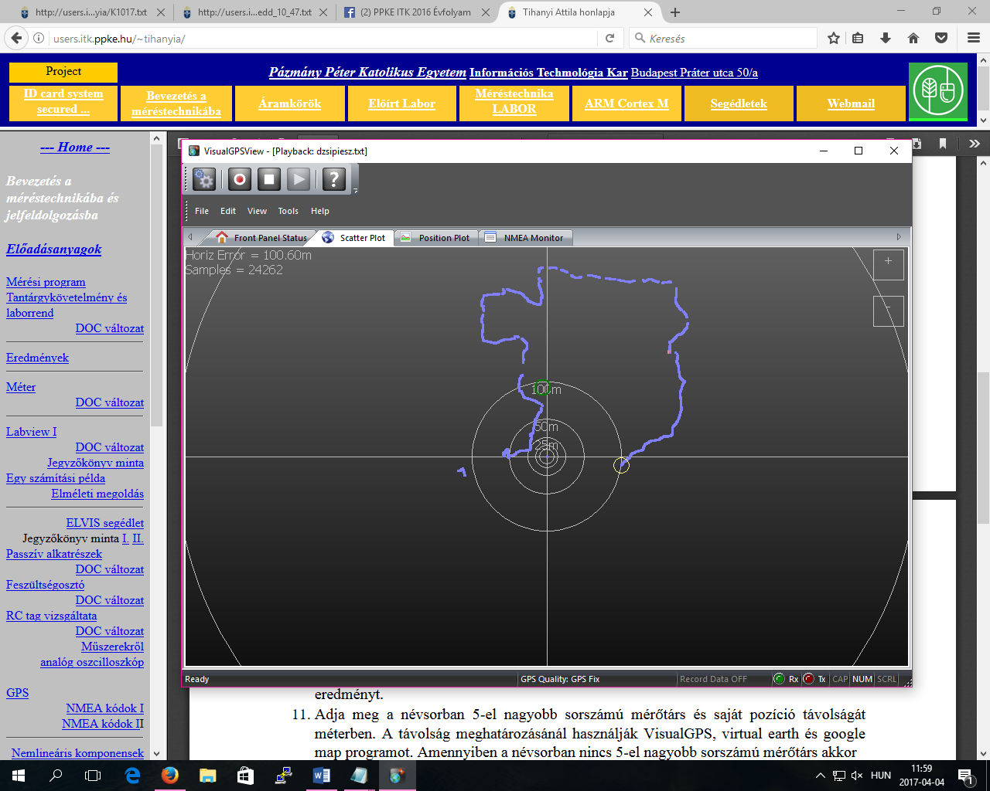

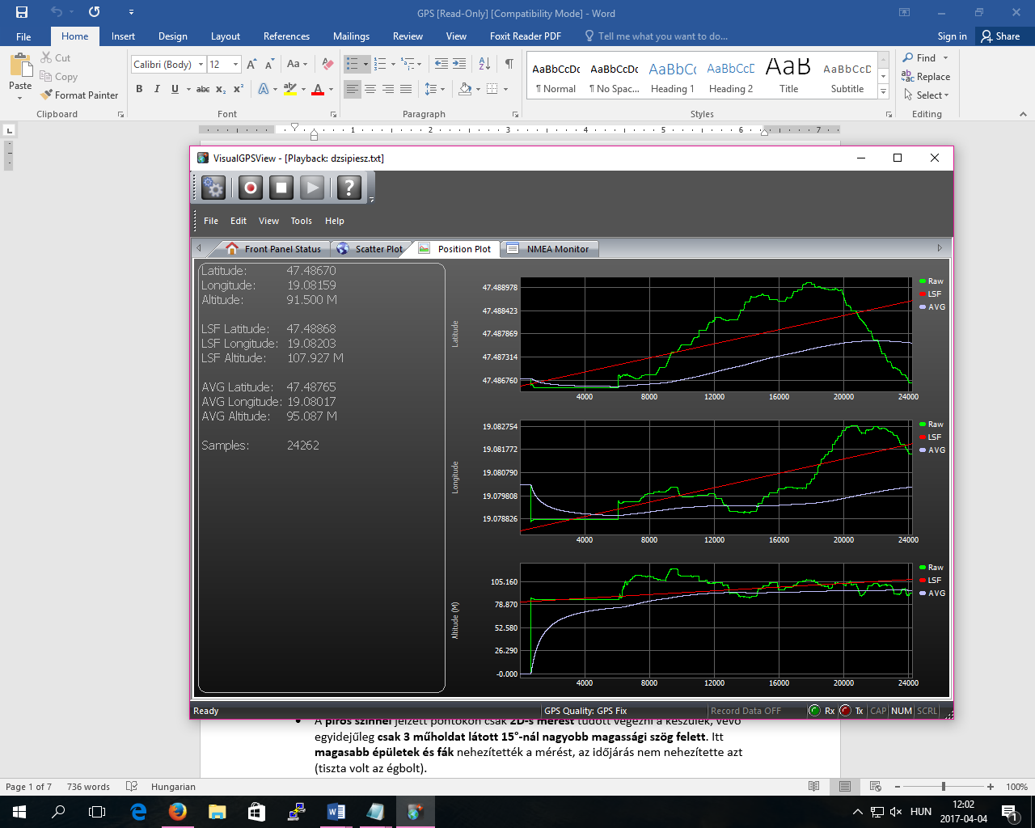

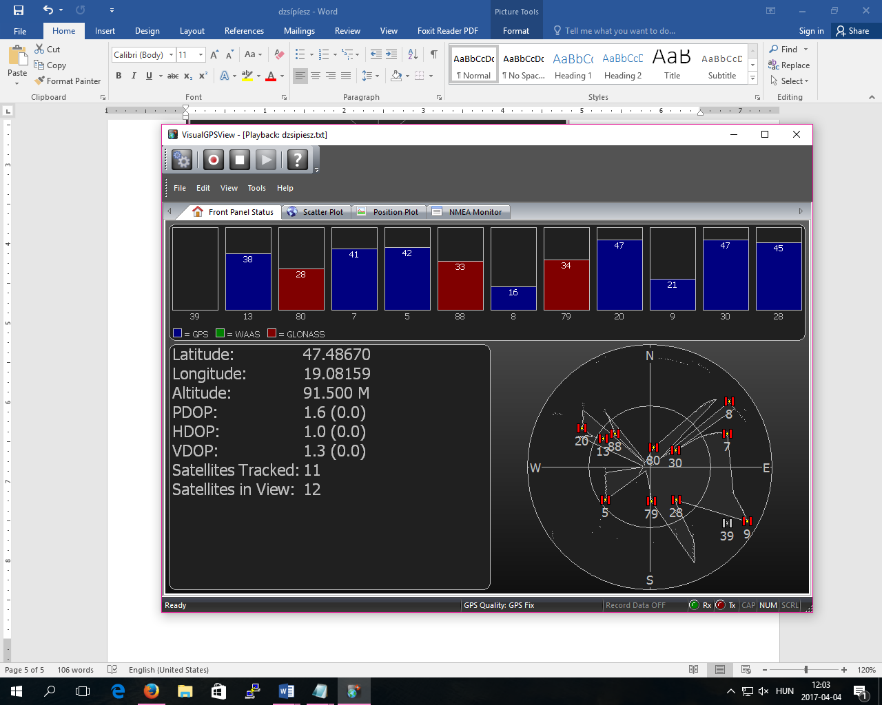

Mindenki magának

* **Időpont**: **UTC** szerinti **08:08:10**.
* **Hely**: É. Sz. 47° 29,3115’, K. H. 19° 5,1645’ = **É. Sz. 47° 29’ 18,69”, K. H. 19° 5’ 9,87”,**

(a perc törtrészét beszorozva 60-nal megkapjuk, hogy az hány másodperc)

* **Position Fix:** **Valid** (1),
* **Fogható jelű műholdak száma: 7**;
* **GDOP: 1.6 m** (ennél a mérésnél ez meglehetősen jó),
* **Magasság:** **121,7 m**,
* **Eltérés a WGS-84 ellipszoidhez képest: 41,0 m**

(a geometriai test és a valóság közti eltérés)

* *46 : az átviteli hiba kiszűrésére használt érték.

